Exercise 7.3.
Groups_on_elliptic_curves_over_the_field_GF(P)

Literature:
https://www.youtube.com/watch?v=F3zzNa42-tQ
https://habr.com/ru/post/335906/

Definition:
An elliptic curve is simply a set of points described by the equation:
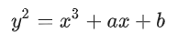
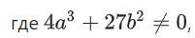
(this is necessary to eliminate special curves). The above equation is called the usual Weierstrass formulation for elliptic curves.

Addition rules and group operation.

a) Points P and Q are different

b) Two identical points (P=Q)

c) Points P and Q on the same vertical line

d) Scalar multiplication.

An example of constructing a cyclic group on an elliptic curve

Exercises for independent work.

1.1) Construct a graph of an elliptic curve.
1.2) Find all points of the group over the field GF(p).
1.3) Find the order of the group.
1.4) find the order of each subgroup.
1.5) Find a group generator and build a group.
1.6) For each subgroup, find a generator and construct a subgroup.
An approximate version of the program for performing points 1.1 – 1.6 is located in the file “7_3_Groups on elliptic curves(Prog).docx

Variants for 1.1 – 1.6

Variant |  |  |  | Variant |  |  |  | Variant
N | p | a | b | N | p | a | b | N | p | a | b
1 | 19 | -4 | 9 | 10 | 13 | -7 | 10 | 19 | 19 | 2 | 2
2 | 29 | -4 | 9 | 11 | 11 | -7 | 10 | 20 | 29 | 2 | 2
3 | 31 | -4 | 9 | 12 | 23 | -7 | 10 | 21 | 29 | 2 | 5
4 | 19 | -5 | 3 | 13 | 11 | 2 | 2 | 22 | 29 | -7 | 10
5 | 17 | -5 | 3 | 14 | 13 | 2 | 2 | 23 | 19 | -7 | 10
6 | 17 | -3 | 6 | 15 | 17 | 2 | 5 | 24 | 17 | -7 | 10
7 | 23 | -7 | 9 | 16 | 19 | 2 | 5 | 25
8 | 23 | -5 | 9 | 17 | 23 | 2 | 5 | 26
9 | 29 | -5 | 9 | 18 | 23 | 2 | 2 | 27

Super task number 1.
Over the field GF(R2) find parameters a and b such that the group order is a prime number.

Super task number 2.
Over the field GF(R1) find parameters a and b such that the order of the group is equal to zero.

Variants for super tasks
Variant |  |  | Variant |  |  | Variant
N | R₁ | R₂ | N | R₁ | R₂ | N | R₁ | R₂
1 | 29 | 1187 | 10 | 67 | 1109 | 19 | 103 | 1051
2 | 31 | 1181 | 11 | 71 | 1103 | 20 | 107 | 1049
3 | 37 | 1171 | 12 | 73 | 1097 | 21 | 109 | 1039
4 | 41 | 1163 | 13 | 79 | 1093 | 22 | 113 | 1033
5 | 43 | 1153 | 14 | 83 | 1091 | 23 | 127 | 1031
6 | 47 | 1151 | 15 | 89 | 1087 | 24 | 131 | 1021
7 | 53 | 1129 | 16 | 97 | 1069 | 25 | 137 | 1019
8 | 59 | 1123 | 17 | 151 | 1063 | 26 | 139 | 1013
9 | 61 | 1117 | 18 | 101 | 1061 | 27 | 149 | 1009

All of the group:
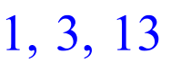
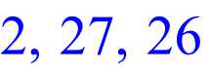
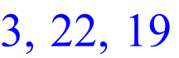
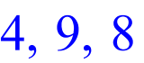
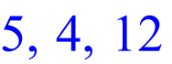
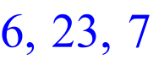
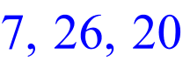
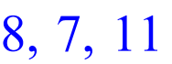
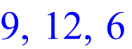
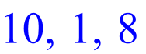
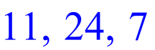
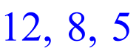
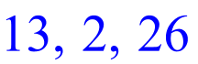
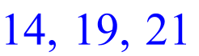
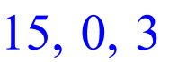
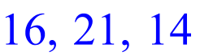
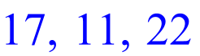
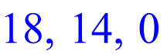
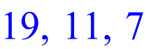
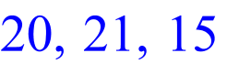
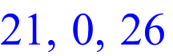
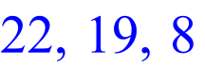
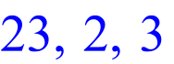
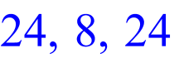
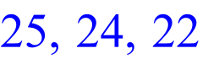
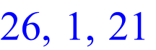
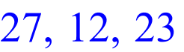
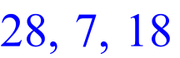
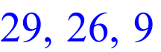
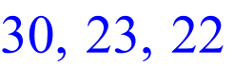
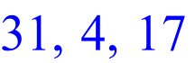
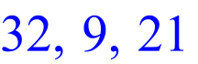
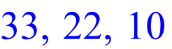
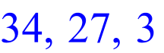
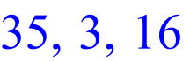
Error, numeric exception: division by zero

Subgroup (0,3)
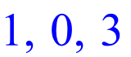
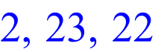
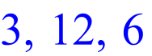
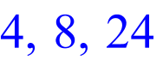
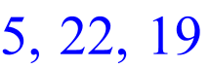
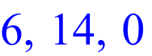
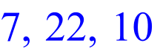
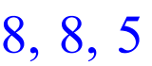
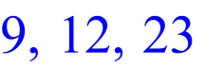
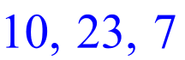
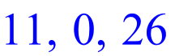
Error, numeric exception: division by zero
Subgroup (1,8)
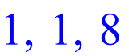
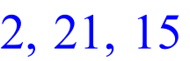
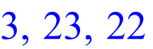
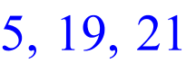
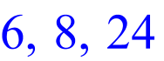
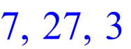
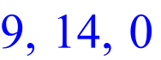
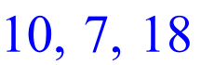
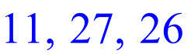
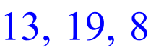
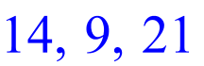
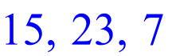
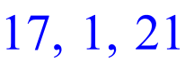
Error, numeric exception: division by zero
Subgroup (4,1)
> 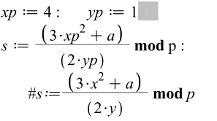
Error, missing operation
Subgroup (8,5)

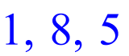
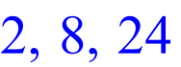
Error, numeric exception: division by zero

Subgroup (9,8)
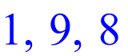
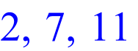
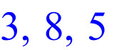
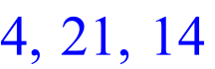
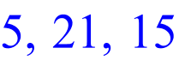
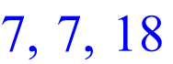
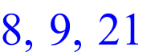
Error, numeric exception: division by zero

Subgroup (12,6)

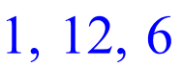
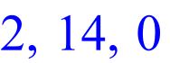
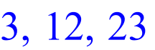
Error, numeric exception: division by zero

Subgroup (14,0)

> 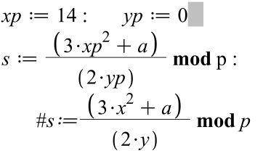
Error, numeric exception: division by zero

Subgroup (19,8)

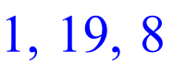
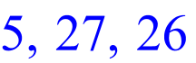
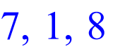
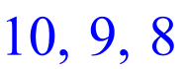
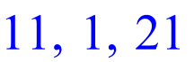
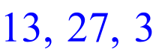
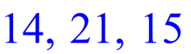
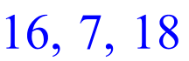
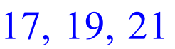
Error, numeric exception: division by zero

Subgroup (21,14)

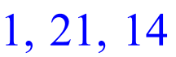
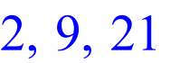
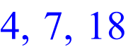
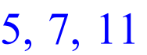
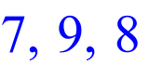
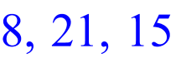
Error, numeric exception: division by zero

Subgroup (22,10)

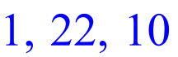
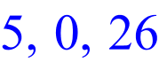
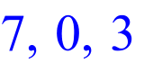
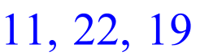
Error, numeric exception: division by zero

Subgroup (23,7)

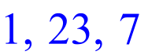
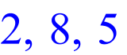
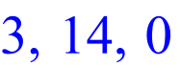
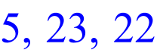
Error, numeric exception: division by zero

Subgroup (27,3)

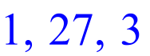
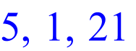
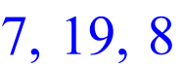
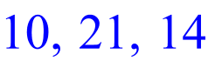
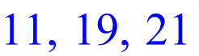
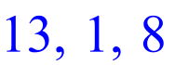
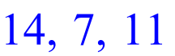
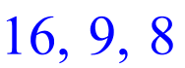
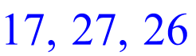
Error, numeric exception: division by zero

